Let’s compare the two number systems
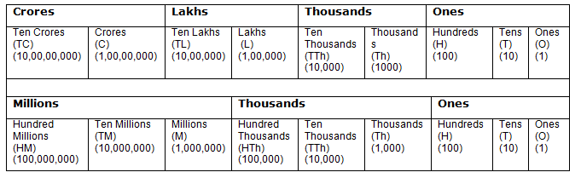
From above comparison we observe that
100 thousands = 1 lakh
1 million = 10 lakhs
10 millions = 1 crore
100 millions= 10 crores

